## Elephant Energy Implementation POC: Royce *(IM to fill)* CX POC: *[IMP to Add]*

### 

| Notes Sections   *(AE to fill if they have, Implementation to be completion DRI on handoff)*   * Info on how merchant bills * 2 invoices for a myriad of products and discounts (rebates). First invoice goes out on signing, second goes out when the job is complete. Ops team will send email trigger when job is complete for the second invoice to go out. Each invoice is half the total amount   1) What is the merchant temperament?  Major callout around this team being amenable. They are looking to us to help them get their AR in order, they have ideas but are open to ours based on what’s realistic   * Jon Schwartz-Frac CFO very friendly, very bright - huge champion for tabs. Straight shooter * Jade - Accountant, quiet but will be your main contact   Only call out is rebate APIs to get rebate data into Tabs. Want to do it after some additional scoping and are very open to our feedback since we are experts in the field  3) What are the Tabs features that the key POC cares about?  Elephant Energy wrote the future state slide themselves on my business case, this is what they wrote: **A Fully Integrated Revenue Automation Platform**   * + Invoices automatically created, sent, and cash applied   + Customer data automatically scraped from contract * **Month End Reduced to Days**   + Tabs integrates with bank and stripe to automate cash application based on geography and type of payment   + One central billing tool marking invoices paid in real time and auto-synced to QBO   + Elephant team can stay laser focused on driving revenue and other product development needs * **AR Expertise and Thought Partnership**   + Tabs work with hundreds of companies across sectors   + A partner to help redesign the process to eliminate as many manual processes as possible * **Audit & SOC II Compliance - Minimize PIIA Exposure**   + All changes in Tabs are kept in an audit log with time and date stamps; SOC II letter available |
| --- |

### Billing model *(Entire Section: Implementation to fill section)*

* Are there unique things about the customer creation process for this merchant?
* Information on how merchant bills
* How contract is broken up
* One off things to know about the merchant

### Contract Processing Steps *(Entire Section: Implementation/Success to fill Post-Go Live)*

1. Steps to process

**PLEASE MAKE SURE THE CUSTOMER IS ASSIGNED CORRECTLY** - the below **should not** be happening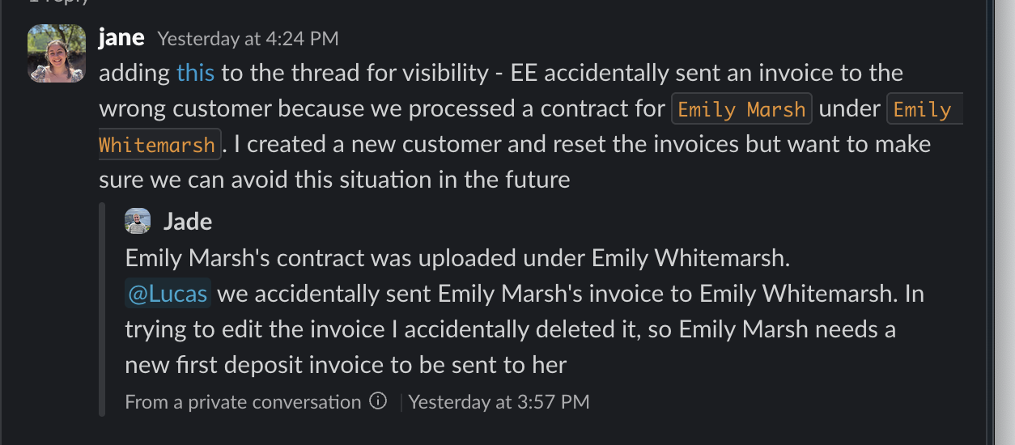

Please also make sure the billing email address is assigned to the customer - you can check in “view customer”

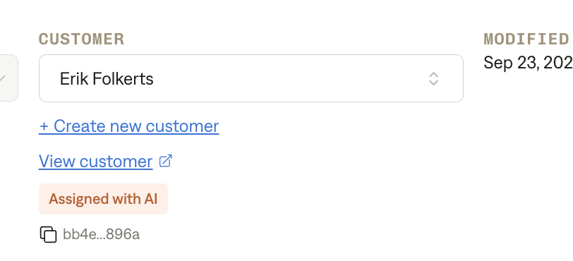

Every project will only have two invoices - their billing structure is that a % of the project is due upfront as a downpayment (usually 50% but not always - please double check the contract signature page for the amount) and the remaining is billed upon completion of the project

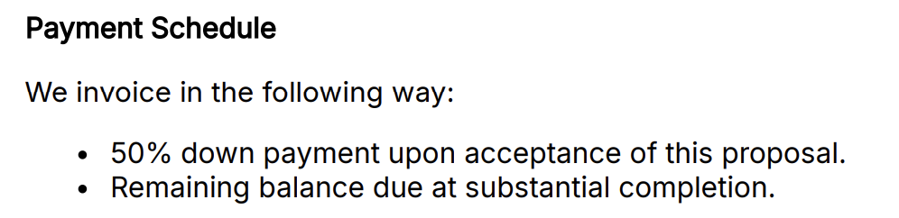

* They also have some edge cases so please read that section

**Integration Items**

* Use “Services” for all products

**QBO Class**

* Set to the state in the customer’s address; if the state is not available in the drop down - leave it blank
* Example below would be Colorado
* **Apply to all BT**

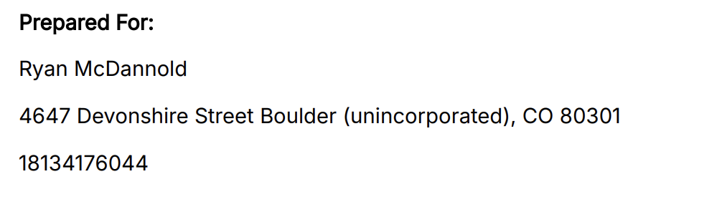

**Locate the “Project Cost Breakdown” page**  


In most cases, the two invoices will equal the Out-of-Pocket Cost (Amount paid to Elephant or Financed) circled in red.

**The first invoice should be created as followed:**

* **Item Name:** “Downpayment”
* **Total Price:** use the downpayment amount listed on the contract - usually on the signature page. Can also check for “Payment Schedule” if it’s not on the signature page



* + If no downpayment amount is listed, default to 50% of the Out-of-Pocket Cost (in this case 50% of 16,600)
* **Service Start Date:** 1 year from the date of signature
  + if not available, use 1 year from the prepared by date on front page
  + **Total months of service:** 1 (recognize revenue in the month they send the invoice)
* **Billing Terms:**
  + **Start Date:** use date of last signature (usually toward the end of the document) or if none, use the date of the proposal (on pg 1)
  + **#of periods:** 1
  + **Frequency:** none
  + **Net terms:** 0 (bill in advance, due start of period or bill first of period)

**The second invoice should be created as follows:**

* List out every line item on the Project Cost Breakdown as a billing term up until the “**Out of Pocket Cost (Amount paid to Elephant or Financed)”**
  + Ignore all line items after “**Out of Pocket Cost (Amount paid to Elephant or Financed)”** (any credit that says direct to customer should be ignored)
  + DO NOT include totals e.g. “**total cost” or “total point of sale rebates”**
* For example, the first line item would be processed as follows:
  + **Item Name:** “3 Ton Cold Climate Mini-Split Heat Pump + 3 Wall Heads, 1 Ceiling Cassette”
  + **Total Price:** $24,415
  + **Service Start Date:** 1 year from the date of signature
    - if not available, use 1 year from the prepared by date on front page
    - **Total months of service:** 1 (recognize revenue in the month they send the invoice)
  + **Billing Terms:**
    - **Start Date:** use one month after the Billing Start Date you used in the 1st invoice
    - **#of periods:** 1
    - **Frequency:** none
    - **Net terms:** 0 (bill in advance, due start of period or bill first of period)
* Follow the above format for all the other line items
* Have to also create a BT in the second invoice for the downpayment as follows:
  + **Item Name:** “Downpayment Credit”
  + **Total Price:** negative amount of the downpayment
  + **Service Start Date:** 1 year from the date of signature
    - if not available, use 1 year from the prepared by date on front page
    - **Total months of service:** 1 (recognize revenue in the month they send the invoice)
  + **Billing Terms:**
    - **Start Date:** use one month after the Billing Start Date you used in the 1st invoice
    - **#of periods:** 1
    - **Frequency:** none
    - **Net terms:** 0 (bill in advance, due start of period or bill first of period)

**\*\**if the sum of the line items don’t match the total out of pocket costs listed - use the sum of the line items.\*\****

**Additionally: Item descriptions** have to be added for the main products (usually a heat pump or water heaters or both)

* Look for the System Designs page (usually follows the Project Cost Breakdown)
* Include the following categories in the description for the product (e.g. “Heat Pump”)
  + Outdoor Unit model number
  + Indoor unit model number
  + AHRI number
  + EER2 number
  + SEER2 number
  + HSPF2 number
  + List all of the above in the item description separated with a semicolon (;)
* The item description for the screenshot example below would be this:
  + MXZ-SM42NAMHZ2; AHU - PVFY-P48NAMU-E1; AHRI 213248940; EER2 11.02; SEER2 16.2; HSPF2 9.1
  + Contractid: be806827-9baf-4a26-b063-b3400e87b573



Another example on the same contractID:

* Item Description for Item (Heat Pump Water Heater) would be: HPTS-66; AHRI 208531171



The invoices you create will look like this:

**First invoice:**

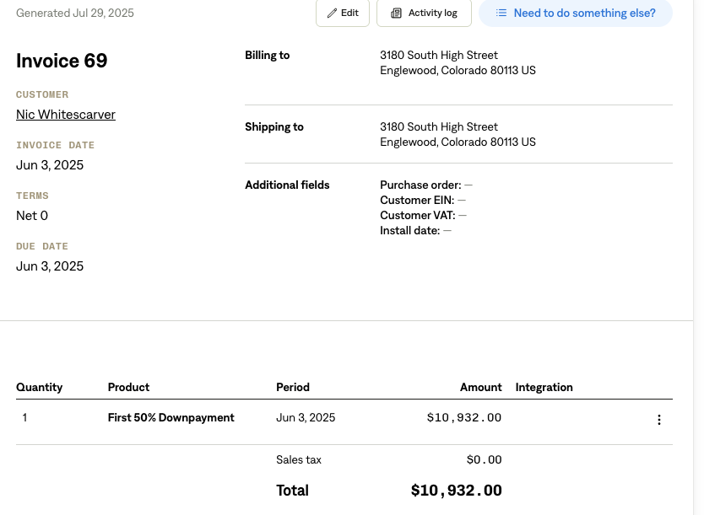

**Second invoice:**

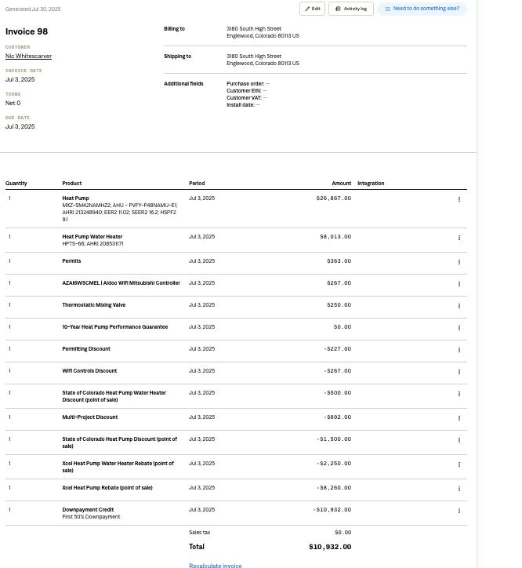

1. Anything to ignore in contracts?

All line items below “Out-of-Pocket-Costs”

1. Specifics processing things the merchant has requested that may differ by contract (e.g. always back-date invoice date to final day of the month)  
   **CHANGE ORDERS**

Make edits to the original contract BT:

* Change orders will always take effect after the first 50% deposit invoice has been sent/paid. Only the final invoice will be impacted.
  + You do not need to change the amount of the “Downpayment Credit”
* If they’re removing something:
  + just the price of that item would change to $0
* If they're adding or changing the price of something:
  + List out the Item Name as “Change Order – ‘Item Name’”
* ~~Make sure you apply any change orders made to point of sale incentives/rebate line items to the subcustomer contract as well (read section below)~~

**~~Point of Sale Incentives/Rebates~~**

* ~~Duplicate the contract and create a sub-customer titled “[Main Customer] Customer Incentives”~~
  + ~~Once created this will show up in garage as “[main customer]: [main customer] customer incentives”~~
* **~~ONLY~~** ~~process the Point of Sale Incentives/Rebates (circled in purple below) as BT~~
* ~~Process these as a~~ **~~positive (+)~~** ~~BT~~
* ~~BT fields should follow the BT that were created for the second invoice~~ **~~with the following exception:~~**
  + ~~Merchant wants to track these on separate invoices so just set the billing start date one off from each other e.g. if billing starts 6/12 for one product, make it 6/13 for the second product, 6/14 for the 3rd product etc.~~



**Example Contracts:**

1. Be806827-9baf-4a26-b063-b3400e87b573
2. Dc978450-b185-4ecb-b66d-cb2fa92d4add
   1. 0681b238-373e-4c7e-8633-015743cbee64 (change order, same customer)
   2. ~~51ebaed1-8991-423b-bc2d-87e605afcc81 (customer incentives contract)~~
3. 9f4d0d7a-7b59-4557-a300-4091ea0764be (upfront discount)

### Edge Cases

*Upfront discount*

* Customers will get a 3% discount for paying the full amount upfront (vs two separate payments)
* For contract processing: if first deposit amount is 0, assume payment is upfront and add 3% discount on the 2nd invoice

*Financing Partner*

* Elephant Energy occasionally works with a Financing partner who requires a special discount line item on the final invoice.
  + note that this does not affect the first deposit amount!
* The line item amount can be calculated from the financing amount which is noted on the contract as “synchrony financing amount”
  + Line item is 7% of the synchrony financing amount, and should be a discount ONLY on the final invoice
    - Item label can be “Synchrony Financing Discount” and should follow the billing term logic of the second invoice
  + Example of what to look for:

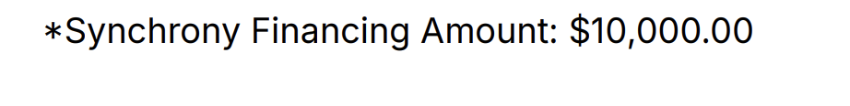

1. Default Service Term
   1. If None Listed, Ops Default is 1 Year
2. Default Net Payment Terms
   1. If None, Ops Default is 0
3. Default Billing Frequency
   1. If None Listed, Ops Default is Monthly
4. How do we handle taxes as a line item?
   1. If None Listed, Ops Default is every tax line item becomes a BT

### Events Processing (if necessary) *(Entire Section: Implementation/Success to fill Post-Go Live)*

* Any important information on events billing

Integration Items Processing (if necessary)  
*(Entire Section: Implementation/Success to fill Post-Go Live)*

* What are the instructions for assigning integration items?
* Example: All Statsig integrations items should be labeled as “Sales”
* Example: All “Pinata” integration items should be labeled as “Software Subscription Bundle” unless otherwise noted by Merchant

Post Processing Communications (if necessary)  
*(Entire Section: Implementation/Success to fill Post-Go Live)*

* Does the Ops Team need to notify anyone on the team re: completion of processing batches in Implementation or Active phase?
* Who needs to be notified and when?
  + Example:
    - Who: Customer Success [Azmat Aziz] needs to be notified
    - Where: Messari internal merchant channel
    - When: contracts are processed [Merchant Phase: Active]

### Customer Information *(Entire Section: Implementation/Success to fill Post-Go Live)*

* Any important information on specifics customers of this merchant
  + Special memo’s certain invoices require
  + Invoice changes due to merchant/customer relationship

### Feature Requests *(AE to fill for all requests prior to Imp handoff, Imp to fill prior to go-live/Success to fill to fill Post-Go Live)*

None

### Merchant Calls *(AE to fill for all videos prior to Imp involvement, Imp to fill prior to go-live/Success to fill to fill Post-Go Live)*

* Loom recording links by dates
* [Discovery call](https://us-56595.app.gong.io/call?id=2817638347706004849&account-id=5438326708865137474)
* [Demo with just Jon](https://us-56595.app.gong.io/call?id=865436427806761962&account-id=5438326708865137474)
* [Demo with the whole team](https://us-56595.app.gong.io/call?id=231784084368115155&account-id=5438326708865137474)